CTEMPs MATLAB® DTS Toolbox
User Guide

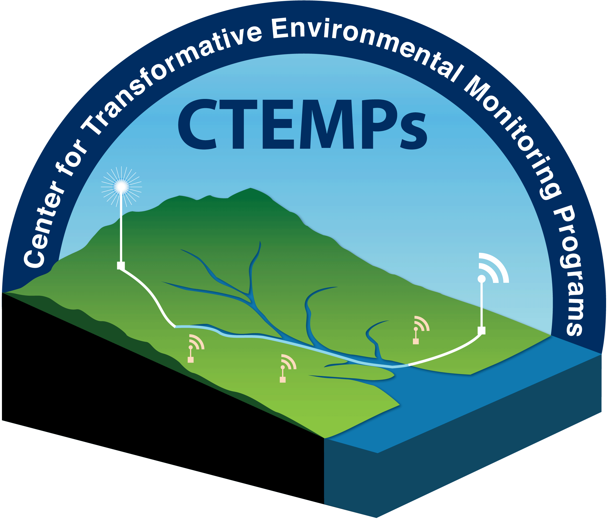

Updated July 2015

Table of Contents
Introduction 3
Toolbox Overview 4
processDTS 5
DESCRIPTION: 5
USAGE: 5
OUTPUT: 7
PROCESSING ERRORS/ISSUES: 7
tref2DTS 8
DESCRIPTION: 8
USAGE: 8
OUTPUT: 9
Processing Errors/ Issues: 9
calDTS 10
DESCRIPTION: 10
USAGE: 10
OUTPUT: 12
Data Processing Example 13
Introduction: 13
Executing CTEMPs MATLAB DTS Toolbox: 14
Parsing DTS file: 15
Background: 15
MATLAB: 15
Adding Reference Bath Temperature: 19
Background: 19
MATLAB: 19
Calibrating DTS Temperature: 21
Background: 21
MATLAB: 22

Introduction
The CTEMPs MATLAB® DTS Toolbox provides simple graphical user interfaces (GUIs) to completely process DTS field data from start to finish. Users can compile raw data files collected by either Sensornet or Silixa DTS systems and calibrate the temperature data in a few simple steps. This User Guide will outline the contents of the toolbox and provide basic instruction for using the toolbox. A comprehensive sample data set with step-by-step instruction has been included.
These ‘beta’ GUIs require specific data files and formats. File not matching expected formats may cause processing errors. This Guide contains specific details for how data may need to be formatted in the event of processing errors. Documentation for each GUI is provided in the manual. These scripts were developed to be used with instruments leased through CTEMPs and have been tested on sample data sets collected from these instruments. Your feedback and recommendation are welcome.
This toolbox is the result of the hard work of both Mark Hausner and Scott Kobs.

Toolbox Overview
There are three steps in processing DTS field data. Each step has a separate MATLAB® GUI. At the completion of each step the user will automatically be prompted to execute the next step. Each step (GUI) can be executed individually through the command line. The Toolbox contains the following GUIs:
  - processDTS – GUI to parse backscatter and PT100 data from DTS output files to a user specified MAT-File (i.e. output.mat)
  - tref2DTS – GUI to add independent reference temperature sensor data from sensors not connected directly to the DTS system to the user specified MAT-file generated by processDTS (i.e. output.mat)
  - calDTS – GUI to calculate calibrated DTS temperature traces from the user specified MAT-file generated by processDTS (i.e. output.mat). Creates a new MAT-File that contains the calibrated temperature data set (i.e. cal_output.mat)
The toolbox includes a total of 12 files. The contents of the tool box are:
- MATLAB Files:
  - calDTS.m
  - calDTS.fig
  - calReport.m
  - processDTS.m
  - processDTS.fig
  - processDTS_legacy.m
  - processDTS_legacy.fig
  - Process_Sensornet.m
  - Process_Silixa.m
  - Process_Silxa_legacy.m
  - tref2DTS.m
  - tref2DTS.fig
  - probe2tref.m

- Other Files:
  - diagram.jpg
  - User Guid.pdf

processDTS

DESCRIPTION:
processDTS parses raw DTS data files from either Sensornet (*.ddf) or Silixa (*.xml) DTS systems that are contained in a single directory. Data is parsed for the user defined reach of cable. The processDTS GUI requires the corresponding processDTS.fig file and both the Process_Sensornet.m and Process_Silixa.m functions.
The legacy functions (processDTS_legacy and Proocess_Silxa_Legacy) are for older Silixa instruments that produce slightly different XML files. This if or use for systems that have not received the 2015 software updates.

USAGE:
Select Instrument:
Specify the type of data files to be processed. Sensornet DTS systems generate files with the *.ddf file extension, Silixa DTS systems generate files with the *.xml extension.
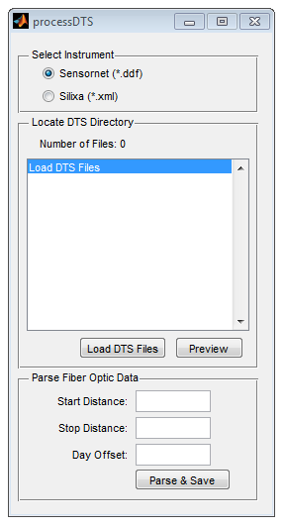
Locate DTS Directory:
Load DTS files by navigating to the directly that contains the *.ddf or *.xml output files to be processed.
Only the files in the selected directory that match the specified instruments file extension will be displayed in the list.
In the case the data is contained in different directories each directory will have to be processed separately. It may be beneficial to combine multiple directories in order to process and generate a single MATLAB® dataset.
Parse Fiber Optic Data:
Set Cable Reach Limits and Time Offset:
Specify the start and stop distance of the reach of fiber to be parsed from the DTS data files. To determine the start and stop distance use the ‘Preview’ button (see below).
Specify any day offset to be applied to the time stamp of each DTS trace in decimal days. In general equipment issued through CTEMPs by default is set to GMT time. Use day offset to correct for any discrepancies between the recorded time in the DTS files and the actual time such as day light savings or time zone corrections.

Preview:
To identify the reach of fiber to process select a data file from the list and click ‘Preview’. A new window will open and the file name, available reference temperatures and un-calibrated temperature as a function of distance will be displayed. From the Preview window data may be plotted by pressing the ‘Plot’ button. From the Plot Preview window use both the pan [] and zoom [] tools to visually identity the reach of fiber to be processed.
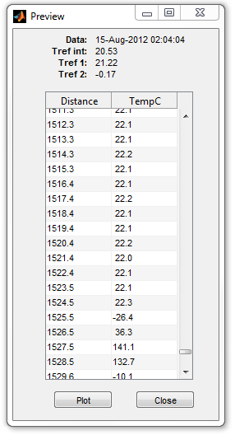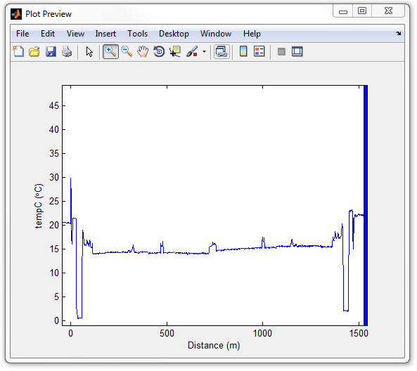
In the figures above the end of the fiber can be seen where the temperature displayed in the tempC column jumps from 22.3 °C to -26.4 °C between 1524.5 and 1525.5 meters. Plotting the data allows for visual identification of cable limits.
Data is read in starting at -50 m. The data from the optical fiber from -50 to 0 m corresponds instrument for internal calibration coil. Data from 0 m on corresponds the optical fiber connect to the instrument.
Parse and Save:
After specifying the reach of fiber to be parsed and the time offset the DTS data files may be parsed and saved. The DTS data files are processed using the Process_Silixa and Process_Sensornet scripts. These scripts may be executed from the command line and contain detailed help files accessible by typing help and the command name (i.e. help Process_Sensornet). The data will be saved to the designated output.mat MAT-file. Processing time varies by DTS system, number of data files and computer. A conservative estimate for processing time is approximately three files per second. A progress bar is used to monitor file processing.
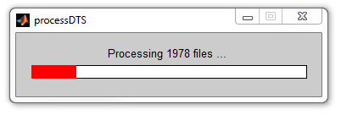
After processing is completed the total processing time is displayed.

OUTPUT:
Output File Contents:
The output.mat MAT-file (*.mat) will contains the following variables:
- distance – measurement points along the fiber (in meters)
- datetime – date and time of each fiber trace
- Stokes – raw Stokes amplitude along the fiber (dimensionless)
- AntiStokes – raw AntiStokes amplitude along the fiber (dimensionless)
- tempC – un-calibrated raw temperature along the fiber (°C)
- tref_int – internal reference temperature (°C)
Depending on the DTS system configuration the output.mat MAT-file may contain the following variables:
- StokesR – raw Stokes amplitude from the reverse trace (dimensionless)
- AntiStokesR – raw AntiStokes amplitude from the reverse trace (dimensionless)
- FOend – user identified end for double ended measurements
- tref_1 – external reference temperature (1) (°C)
- tref_2 – external reference temperature (2) (°C)

PROCESSING ERRORS/ISSUES:
In the event of a processing error the error will be displayed along with a possible cause. Two common errors include changes in the DTS configuration (e.g. sampling resolution) and corrupt data files. When one of these errors occurs the file name that generated the error is displayed and may need to be removed or manually corrected. Data processed up to the point of the error is saved to the designated output.mat MAT-file.

tref2DTS

DESCRIPTION:
tref2DTS provides a way to add reference temperature records to the DTS output.mat MAT-file generated by processDTS. The GUI has been designed to handle data files collected by RBRsolo and Hobo temperature loggers. Data collected by other sensors may be processed by formatting the data into columns of time stamp and temperature and saving the data to either a CSV or Excel file. Data file types and formats are further detailed under USAGE.

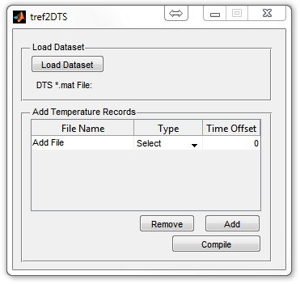
USAGE:
Load Dataset:
Load the DTS output.mat MAT-file generated by processDTS that reference temperatures are to be added to. If continuing directly from the processDTS prompts the output.mat MAT-file will automatically be loaded.
Add/Remove Temperature Record(s):
Use the ‘Add’ button to locate and add reference temperature files. Accepted files include, RBRsolo MAT-file, HOBO CSV file, user general CSV/Excel file where the first column contains the date time and the second column contains the recorded temperature in °C.
Specify the data file type from the drop down menu (CSV [Date,Temp], RBRsolo, HOBO, XLS [Date, Temp]). For more information about file types see File Type and Format.
Enter any time offset for the temperature record in decimal days in the ‘Time Offset’ column such that the recorded time matches that of the DTS data set.
Compile:
Once all data files are loaded, the file type selected and time offset entered the temperature records can be compiled and appended to the loaded DTS MAT-File.
Temperature records are linearly interpolated in time to match the time stamp of each DTS trace. This is completed using the interp1 command in MATLAB®.
The range of the reference temperature time series is checked against the DTS time series to verify that the records fully overlap. In the event that the temperature file does not fully overlap it will NOT be processed or added to the loaded output.mat MAT-file. Use the Time Offset to correct for any time stamp discrepancy.

File Type and Format:
The following data files may be processed using this function:
- CSV [Date, Temp °C]
  - Column 1 – Time stamp
    - For best results format date time as MM/DD/YYYY HH:MM:SS (12 or 24 hour clock time)
  - Column 2 – Temperature in °C
  - Comma delimited
  - No headers
- RBRsolo
  - Export RBRsolo data form the Ruskin software to a MATLAB® MAT-file
    - Ruskin v1.9.1 – File > Export dataset > Matlab MAT
  - Load the exported MAT-file
  - NOTE: date is recorded in the following format DD/MM/YYYY and should not be changed
- HOBO
  - Export only temperature data from HOBOware.
  - The exported data file is a CSV-file
- Excel – [Date Time] [Temperature °C]
  - Column 1 – Time stamp
    - For best results format date time as MM/DD/YYYY HH:MM:SS (12 or 24 hour clock time)
  - Column 2 – Temperature in °C
  - No headers

OUTPUT:
The loaded output.mat MAT-file (*.mat) will have the following variables appended:
tref2DTS_ouput: Cell containing variable name (tref_#), original file name, time offset
tref_#: Interpolated reference temperature to match the variable datetime

Processing Errors/ Issues:
In the event that a data file cannot be processed copy the time stamp and temperature data into an excel file and select the EXCEL option for adding the temperature data to the DTS data set.
All processing errors are printed to the command window. The file name and corresponding date time error will be displayed as well as what range of files may be processed.

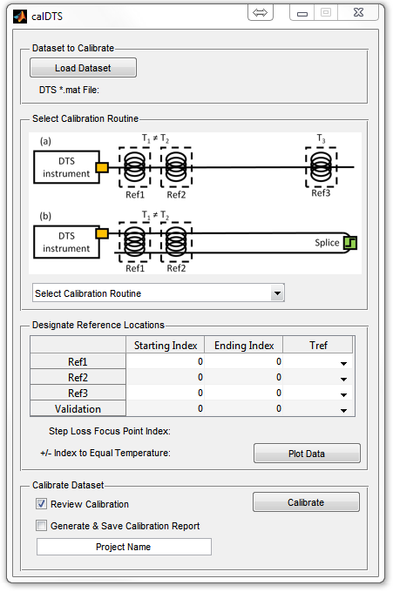
calDTS

DESCRIPTION:
calDTS calibrates temperature data collected from DTS systems using independent reference temperatures located along the fiber. Temperature can be calibrated based on the DTS fiber configuration for the given deployment. The two supported configuration are three point explicit and three point explicit with step loss (splice).

USAGE:
Load DTS data set MAT-File:
Load a MAT-File that contains raw DTS and reference temperature data. Data sets constructed using processDTS and tref2DTS are immediately ready for use with the calDTS GUI.
Select Calibration Routine:
Data can be calibrated using two methods:
- Single ended three point explicit calibration
- Single ended three point explicit calibration with step loss (splice)
Select the routine that matching the configuration of the fiber deployment. Diagrams of these two configuration have been provided.
Define Reference Index Location for Calibration:
Define the index location of each reference temperature. Index location is not the same distance. Use the ‘Plot Data’ identify reference locations (see below). The index value for a specific distance can be identified by manually looking that the ‘distance’ variable in the DTS data.
Select the reference temperature probe form the Tref drop down menu that corresponds to the reference location.
For reference location that are a point enter the same index value for in the Start/End column.
Specify the reach of fiber to be used for validation. If no validation value is available leave the table blank (e.g. zeros [0,0]).
Identify Splice/Step Loss Location:
For calibration with a step loss the index location of step loss focus point must be identified. The focus point often corresponds to the point of symmetry in the dataset.
Specify the number of sampling windows away from the focus point that the temperature is expected to be equal on each side of the splice. This value is must be an integer and has a distance is equal to the sampling resolution multiplied by the integer number entered.
It is important to pick a point where the temperature is the same on both sides of the slice to be able to account for the step loss in the signal.

Plot Data:
Plot data will display both the DTS temperature data and reference temperature data. The upper plot is Array Index vs. Un-calibrated Temperature (variable tempC). The plot uses index value instead of distance as the index value is needed in the calibration GUI. The corresponding distance can be determined by examining the distance array (i.e. >>distance(index)).
The lower plot contains the time vs temperature for each reference temperature. The legend identifies which dataset corresponds to the given variable name.

Calibrate:
Once all the calibration parameters have been entered the data set may now be calibrated.
Review Calibration – this box is automatically checked and will generate a figure to review the quality of the calibration. The figure contains three plots:
- Calibrated DTS Temperature vs. Reference Temperatures
- Differential Attenuation vs. Time
- Gamma vs. Time
After the calibration is completed this figure can be regenerated using the Review Calibration button that becomes visible only after the data set has been calibrated.
Generate & Save Calibration Report – checking this box will generate and save a calibration report as a PDF. The Project Name will be displayed on the report. A sample report can be found in the Data Processing Example. This report summarizes data contained in the output file.
Save:
Once the data has been calibrated the Save button will become visible. At this point the calibration report will be generated if selected and the output data will be saved to the specified output file.

OUTPUT:
The calibrated cal_output.mat MAT-file contains the following variables:
- calTemp – calibrated DTS temperatures
- distance – fiber distance array (from input file)
- datetime – fiber trace timestamp (from input file)
- cal_parameters – structure containing calibration parameters and user input.
  - Da – differential attenuation between anti-Stokes and Stokes signal
  - g – γ(K) photon energy shift
  - C - dimensionless calibration parameter
  - z – calibration reference index location
  - zVAL – validation reference index
  - RMSEavg - average RMSE for all reference points (each reference point is weighted equally).
  - RMSE1, RMSE2, RMSE3 - Root Mean Squared Error (RMSE) for each calibration reference section corresponds to reference locations stored in ‘z’
  - Bais – mean error*for all calibration reference sections
  - valRMSE – RMSE for the validation reference section
  - valBias – mean error for the calibration reference section
- outputfile_Report.pdf – calibration report

“error” is the difference between the calibrated DTS temperature and the reference temperature

Data Processing Example

Introduction:
This example contains step by step directions for processing raw DTS data using the CTEMPs MATLAB DTS Toolbox. This example will cover processing data files, adding independent reference temperature records and calibrating temperature data using both the single ended explicit and single ended explicit with step loss configurations. The data files for this example are contained in the CTEMPs_EX1 directory.
The sample data contains stream temperatures collected from Martis Creek near Truckee, California. A schematic of the deployment can be seen in Diagram 1. This diagram will be referenced later in discussions and is provided to help understand and interpret the dataset.

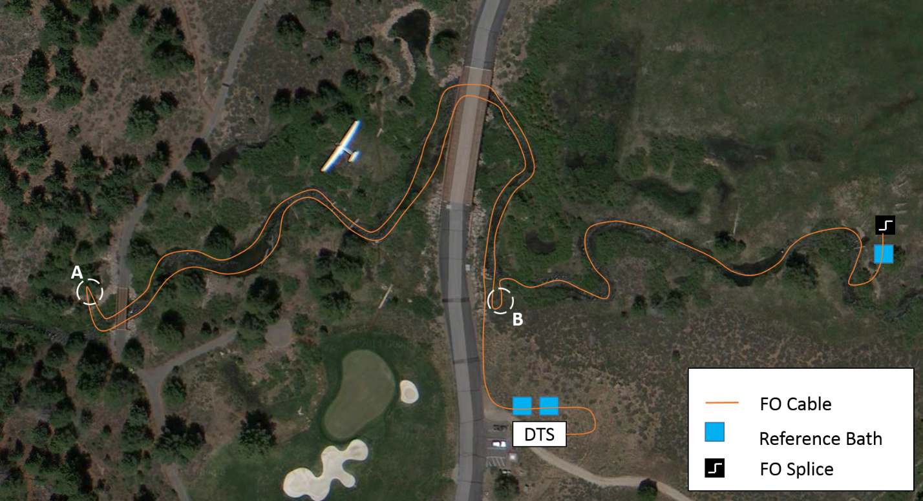
Diagram 1 –DTS deployment schematic at Martis Creek in Truckee, CA. The fiber optic (FO) cable was deployed in a stream bed. Circles A and B represent location were the cable was place on the bank, this creates easily identifiable reference points in the DTS data set. Three reference baths were placed along the deployment, two near the instrument and one at the terminal end of the cable. The optical fibers were spliced at the terminal end of the cable. Aerial imagery taken from Google Maps.

Executing CTEMPs MATLAB DTS Toolbox:
In order to execute the GUIs in the DTS Toolbox the current working directory must be set to the DTS Toolbox directory. If the tool box is to be used regularly it may be convenient to add directory to the MATLAB toolbox.
To set the working directory click on Browse to folder () and select the DTS toolbox folder.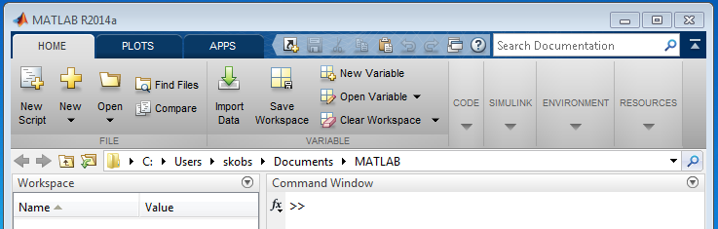
At this point all of the GUIs in the toolbox may be execute from the Command Window.
To execute one of the DTS GUIs type the GUI name (i.e. processDTS, tref2DTS, calDTS) in the Command Window and press Enter.
To regularly use the DTS Toolbox use Set Path on the Home ribbon under Environment. From the Set Path dialog window press ‘Add Folder…’ and navigate to the location of the DTS Toolbox and select the folder. Click ‘Save’ to store add the Toolbox to MATLAB®. The GUIs may now be called at any time from the command window without having to set the working directory to the toolbox.

Parsing DTS file:

Background:
DTS systems generate *.ddf (Sensornet) or *.xml (Silixa) files for each fiber trace. These files contain Stokes, anti-Stokes, distance, and reference temperatures for an individual fiber trace. The raw data is typically organized in directories by channel, year, and month. In order to post process and calibrate the DTS data into temperature measurements it is necessary to parse the data from each file and generate a single dataset that contains the data from these DTS files. In this step we will parse data from the individual files (*.ddf or *.xml) and build a single MATLAB MAT-file of the dataset.
Depending on project needs it may be beneficial to organize all of the DTS output files, from a single channel, into one directory for processing, doing so will yield a single data set which contains data from every trace of the deployment. This step is usually only necessary if the field data is collected in multiple months.
The DTS output files for this example are located in the directory CTEMPs_EX1\channel1_ddf

MATLAB:
- In the Command Window type processDTS and press enter.
The following window will be opened:

- Select the Instrument type.
For this example the DTS data files are from a Sensornet Oryx system and have the *.ddf file extension.
- Load the DTS file by clicking on ‘Load DTS File’.
Navigate to C:\ … \DTS_Toolbox\CTEMPs_EX1\channel1_ddf and press Select Folder.
The list window will be populated with the files in the directory that have the *.ddf file extension as seen below.
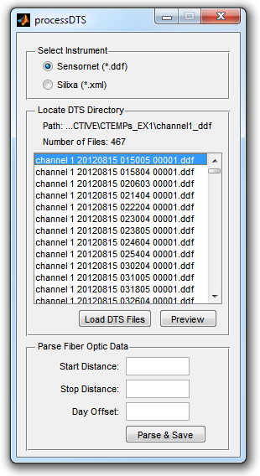
- Determine the reach of optical fiber to parse for the DTS file.
In order to ensure data was collected for the entire length of the fiber the instrument was configured collect data to a distance known to be greater than the fiber length. Therefore, the end of the data files contain noise/garbage data. The reach of data to be parsed can be determined by using the ‘Preview’ button. Select a file and click ‘Preview’ for this example we will look at the first file ‘channel 1 20120815 015005 00001.ddf’.

The preview window will display the distance and temperature measurements along the fiber. From the Preview window the data from the selected file can be plotted using the ‘Plot’ button in the lower left. The two windows can be seen bellow.
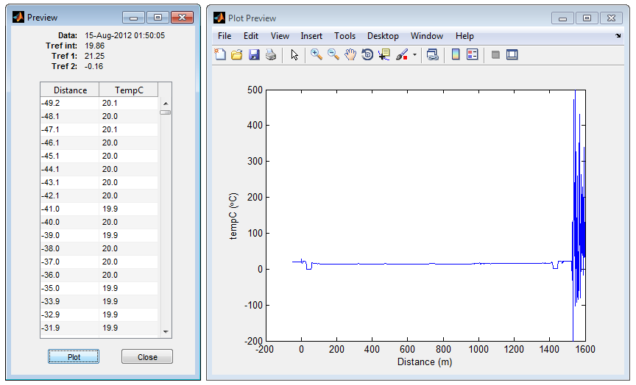

The noise/garbage data beyond the end of the fiber can be seen in the plotted data window. For this example we want to exclude this data as it is not from the reach of the fiber. The end of the fiber can be determined by scrolling through the Preview Window or by using the zoom and pan tools in the Plot Preview Window.

At a distance of 1525.5 m there is a jump in the temperature from 21.6°C to -30.9 °C. This jump corresponds to the end of the fiber. Additionally, at the start of the data set there is ~50 m of data before a distance of zero. This section corresponds to the internal calibration coil located with the instrument. The reach of fiber connect to the instrument starts at 0 m.

For this example the reach of fiber that we are interested in is from 0 m to 1525 m. This will parse all measurements between 0 m and 1525 m.

- Day Offset:
For this example we will not use the day offset. Enter a value of zero.

- Parse & Save
Specify the file name and location to save the raw DTS data and click Save.
At this point a progress bar will be displayed.
After processing the DTS data files you can automatically continue to add reference bath temperatures by clicking yes when prompted.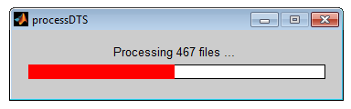
- Output File:
The output file can be opened into the MATLAB Workspace. It will contain eight variables.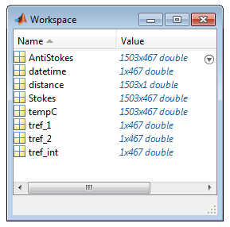

Adding Reference Bath Temperature:

Background:
In order to calibrate the temperature data three reference temperatures are needed along the fiber. Each DTS instrument can have up to two PT100 temperature sensors directly connected. Depending on the deployment and configuration temperature loggers can be placed at known location along the deployed fiber. Data from these loggers needs to be added to the raw data set for calibration.
The PT100 temperature probes connect to the DTS system record temperature at the time of the fiber trace. Independent loggers, however, are set to record tempter along the fiber at fixed time intervals and it is unlikely to correspond exactly to the time a specific DTS fiber trace. Therefore, these loggers must be interpolated in time to match the timestamp of each specific DTS fiber trace. This process is competed using linear interpolation using the interp1 command in MATLAB.

MATLAB:
- In the Command Window type tref2DTS and press enter
The following window will be opened:
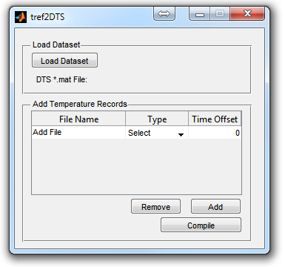
This window will automatically be opened if you continue from processDTS.

- Load DTS Dataset
Click ‘Load Dataset’ and navigate to the location of the file you created using the processDTS GUI. If you continued directly from processDTS the file will automatically be loaded and should be displayed in the ‘DTS *.mat File:’ field.

- Add Temperature Logger Data File
For this example navigate to …\DTS Toolbox\CTEMPs_EX1 and select martis_bath3.

- Select the Data File Type
The martis_bath3 file is an excel file with timestamp in column 1 and temperature in column 2.
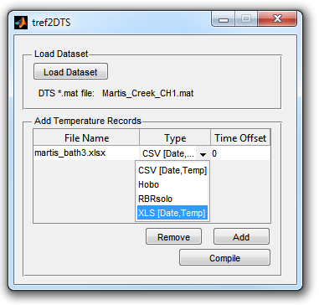
- Specify Time Offset
For this example there is no time offset. Enter a value of zero

- Compile The Data Files
Click ‘Compile’ to append the MAT-file. A new variable will be added to the file that contains the interpolated reference temperatures.

- Appended MAT-File
In this example the data will be saved the variable tref_3. The variable terf2DTS_ouput contains a summary of what file each variable was generated from and the user specified time offset.
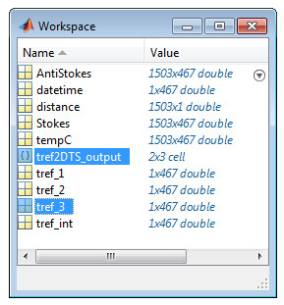

Calibrating DTS Temperature:

Background:
DTS systems measure Raman backscatter (Stokes & anti-Stokes) and temperature is calculated. The physical configuration, number of reference sections, of the DTS deployment will govern the calibration routine. The two calibration routines are capable of calibrating single ended configurations with three calibration baths or duplex singe ended configurations with two calibration baths before and after the slice.
The data set in this example can be calibrated using both methods and was provided as an example to demonstrate both calibration techniques. The graph below shows a single temperature trace from 15-Aug-2012 at 15:10:04. The data is mirrored around the fiber optic splice located near ~740 m. Therefore, a three section explicit calibration can be completed for the reach of fiber before the splice using the three reference baths shown in diagram 1. Alternately, if there were not three reference section located to the ‘left’ of the splice a three point explicit with step loss calibration would be necessary. In this case since the two fibers in the cable where spliced together, the trace is mirrored and the two fiber passes through both calibration baths twice. How to select reference locations will be further detailed below.

MATLAB:
- In the Command Window type calDTS and press enter
The following window will be opened:

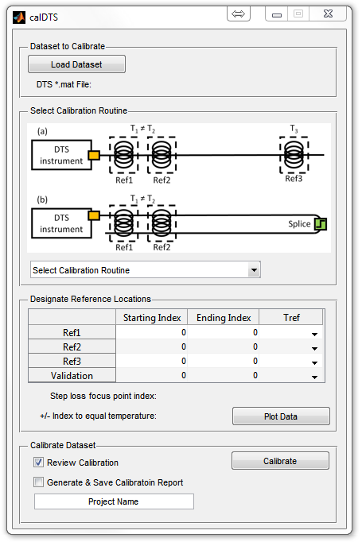

- Load DTS Data Set
Click ‘Load Dataset’ and locate the data set to be calibrated. This is the data set that was created using the processDTS GUI and appended with the tref2DTS GUI

- Select Calibration Routine
The example data set can be calibrated using both routines. When possible we recommend using (a) Three Point Explicit method. It is important that you always select the most appropriate calibration route and use good judgment in selecting fiber reference locations and identifying splices.

- Identify Fiber Reference Locations
This is one of the most important steps. It is recommended that reference section should contain ten observations. Reference baths can easily be identified in the un-calibrated data. Click the ‘Plot Data’ button to plot all the temperature data in the file.

Using the zoom [] and pan [] tools move around the plot to locate the reference baths.

From Diagram 1 it can be seen that two of the reference baths are located adjacent to the instrument and that the third is located near the splice. The reference bath locations (yellow) and splice location (red dashed line) have been highlighted in the figure below.

Input for the reference sections for calibration is the ARRAY INDEX and NOT true fiber optic distance. Data shown in the plots from the calibration are plotted against its array location (ARRAY INDEX). The following plots are ARRAY INDEX vs Un-Calibration Temperature.

Zooming in on the calibration baths near the instrument the following may be seen:

From the above figure the transition from one bath to the other occurs over ~5 observations (27-32) even though the baths are were located adjacent to one another with minimal amount of the fiber exposed. This transition is related to the spatial resolution of the system (different than spatial sampling resolution) and how the instrument integrates back scatter data over the sampling window. Since temperature is integrated over the sampling window it is important to not include the fringes of the reference observations in the baths. For example, while the temperature seems stable at 27 (temperature are linear as we approach from the left) it may be better to use 26 as the end of the first reference bath. Similarly, if the there is sufficient data points in the second reference bath it may be best to select 33 or 34 as the starting location (temperature is linear approaching from the right).
Table of approximate bath locations and reference temperature:
Starting Index | Ending Index | Reference Temp
12 | 26 | Tref_1
33 | 55 | Tref_2
716 | 724 | Tref_3
732 | 740 | Tref_3
1402 | 1424 | Tref_2
1430 | 1444 | Tref_1

- Identify Splice (Step Loss) Location (ONLY FOR STEP LOSS CONFIGURATION)
When calibrating a data set with a splice in the optical fiber there will be a step loss in the observed backscatter signal after the splice. In order to calibrate the data set it is important to identify the location of the splice so that a correct can be applied to raw data to account for the loss in signal caused by the splice. In most cases the splice can be easily identified by locating the point of symmetry in the data.

Below you can see the ambient temperature bath located before and after the splice from ~715-725 and ~731-741. Zooming in more on the splice we can more accurately identify the location of the splice by symmetry at 728.

In order to correct for the step loss a point of identical temperature at equal distances before and after the splice must be identified. Since temperature is a function of the backscatter signal by identifying a point before and after the spice that have the same temperature it is possible to determine a correction for the step loss. In this data set an ambient reference bath is before the splice along the deployment and therefore can be seen just before and after the spice in the fiber trace data. However, an observation in the stream near the stream would also worked had the reference bath not been included.

It is very important to be as accurate as possible when identify bath locations and splices. Not properly identifying the locations and including the fringes of baths will directly affect the quality of the calibration.

Sample screen shots of calibrating the sample data set using both configurations:

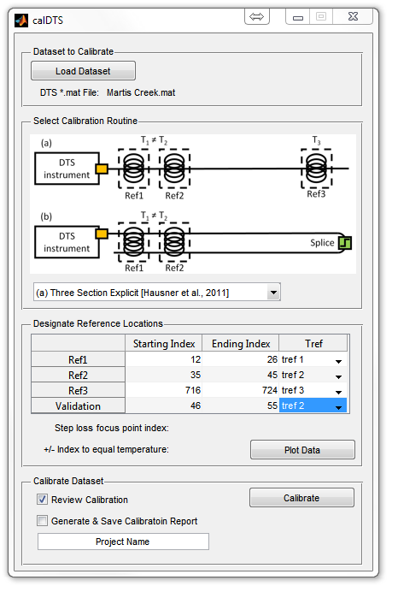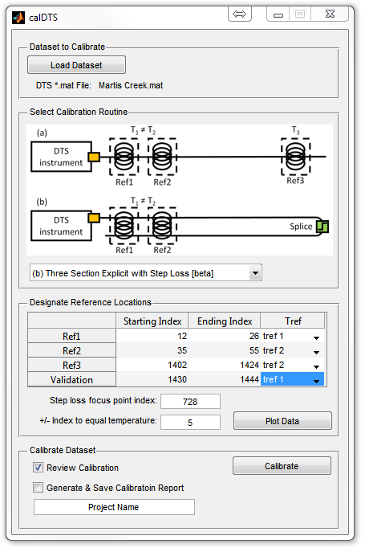

- Calibrate
Once all the data fields have been completed the data set can be calibrated. Calibrating the data set will generate a two new windows.
The first will be a summary of the calibration:

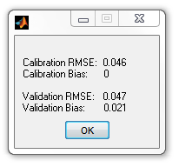
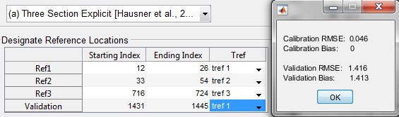

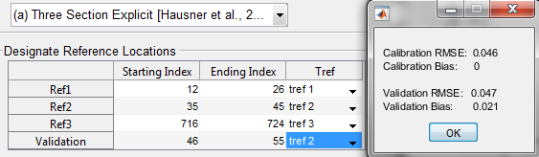

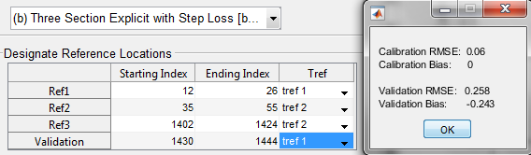
The second will be a plotted summary of the calibration results:
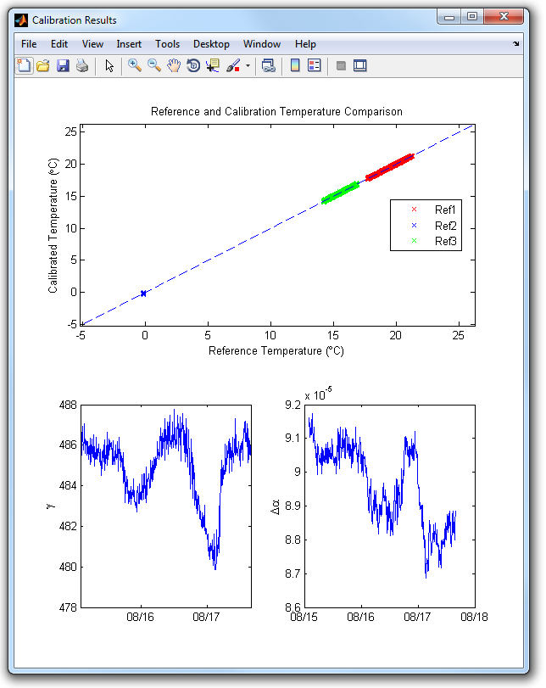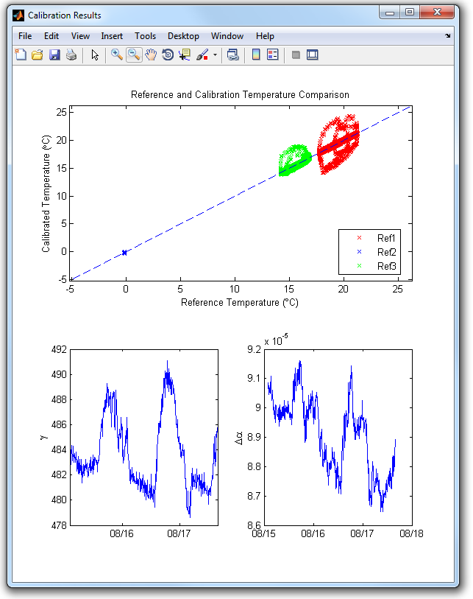
This window will display a comparison of the reference temperature to the DTS calibrated temperature along with a 1:1 line. The figure on the left is a correctly calibrated data set. It can be seen that the points in comparisons plot land on the 1:1 line as expected. However, if there is an error related to the reference locations used the figure on the right shows when incorrect reference baths are selected.

- Save Data
After the calibration is completed the Save button will be visible. At this point is the calibration is acceptable the data set may be saved to the designated output file.

In order to generate and save a calibration report check the box next to ‘Generate & Save Calibration Report’. Enter the Project Name to be displayed on the report. The report will be generated and saved at the same time as the MATLAB output file.

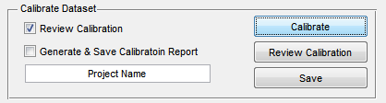

- Output File:
The output file can be opened into the MATLAB Workspace. It will contain four variables. The variable cal_parameters is a structure contains 5 variables. To access data stored in a structure type the structure name followed by a period and the field name you want to access.

For example to access the variable RMSEavg type cal_parameters.RMSEavg in the command line.
